Procedural Steps

Access to Enter Fuel Expenditure through SAP by:

Via Menus | -
Via Transaction Code | ZFI030_F

From the main menu SAP Easy Access screen enter the transaction code in command field : ZFI030_F

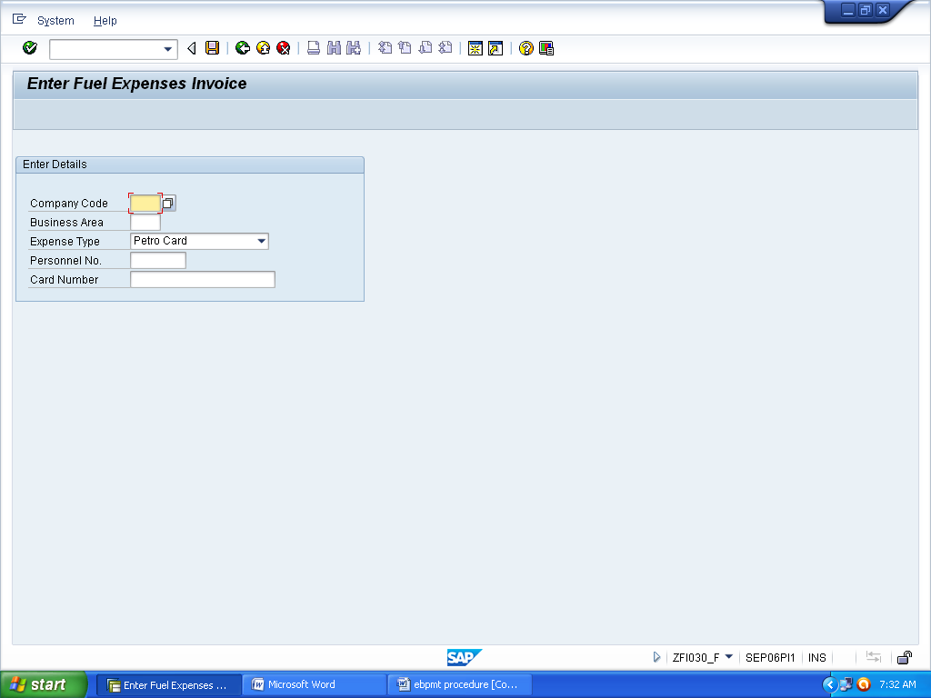

In the Company Code . enter 1030
In the Business Area, enter your Business Area number
In the Personnel No, enter the Personnel No and in the Card Number, select the card number for which the expenditure is incurred from the drop down box and then click ‘Tick’ symbol given at the top of the screen.

The Following Screen will appear:

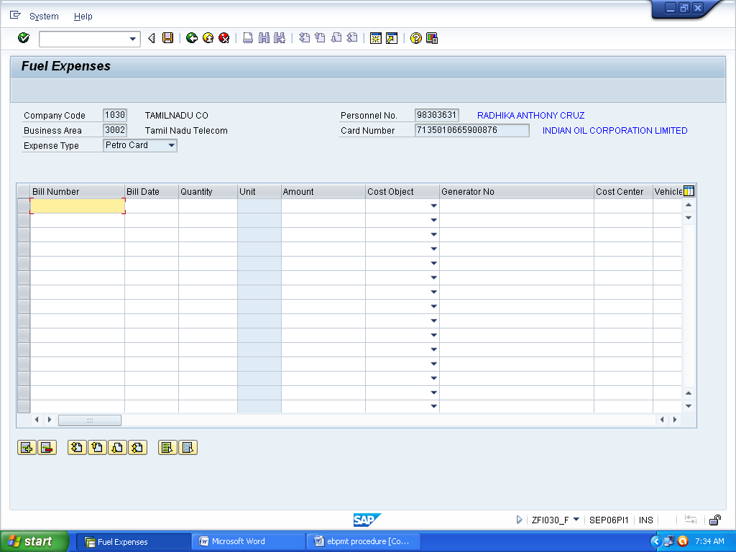

Enter the Bill number, Bill date, Quantity, Amount. In the Cost Object, Select either Vehicle or Generator. If Generator is selected, provide generator no and if Vehicle is selected, provide the vehicle no.

In the Cost center, provide the correct Cost center number.

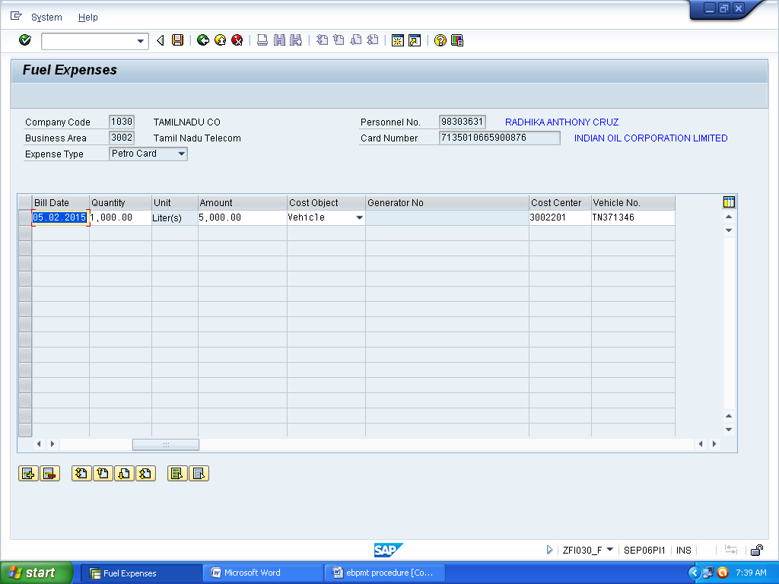

To Enter, Click the Save Button available at the Top of the Screen.The following screen will appear.

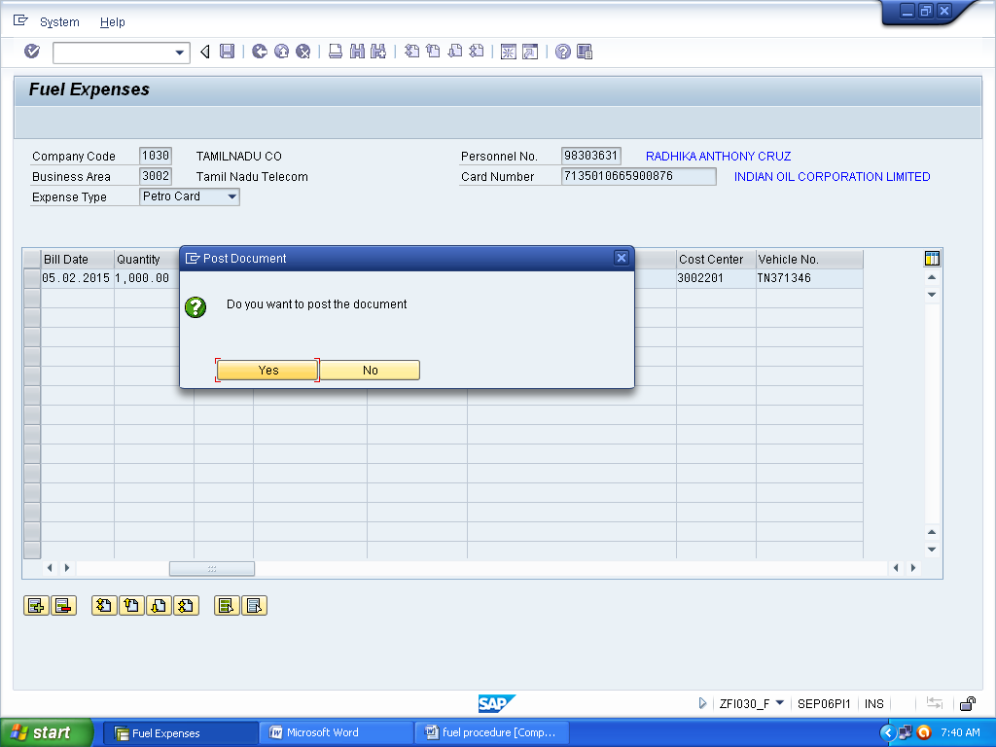

Click ‘Yes’ Button to post the document and note down the Document Number for future reference.

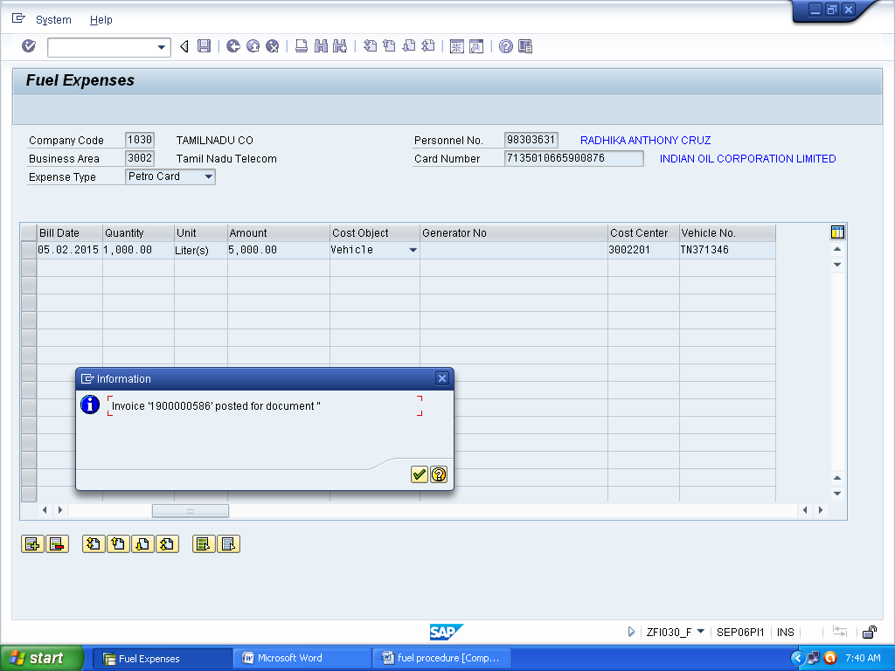

Once it is posted, Enter the Transaction Code : SBWP in the main menu and go to the Inbox and click the particular document.The following screen will appear

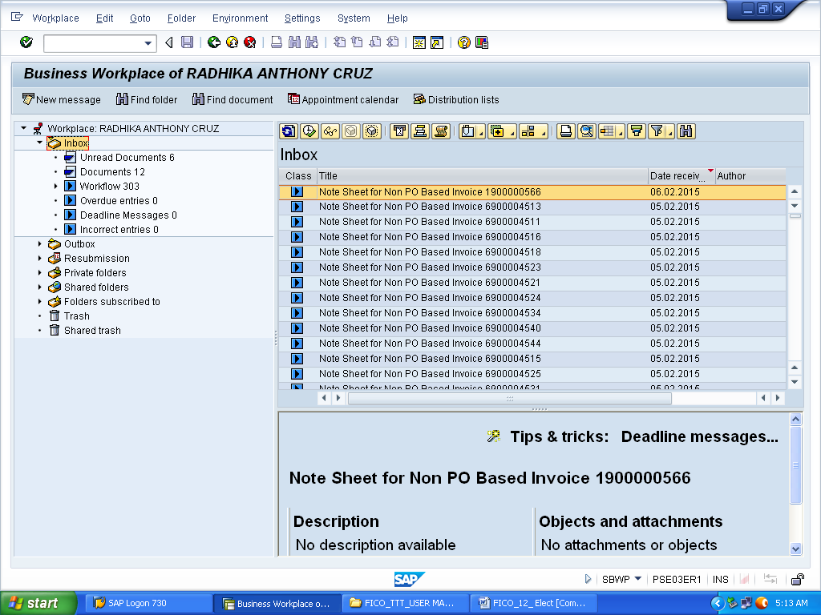

On clicking the document available in the Inbox, the following screen will appear:

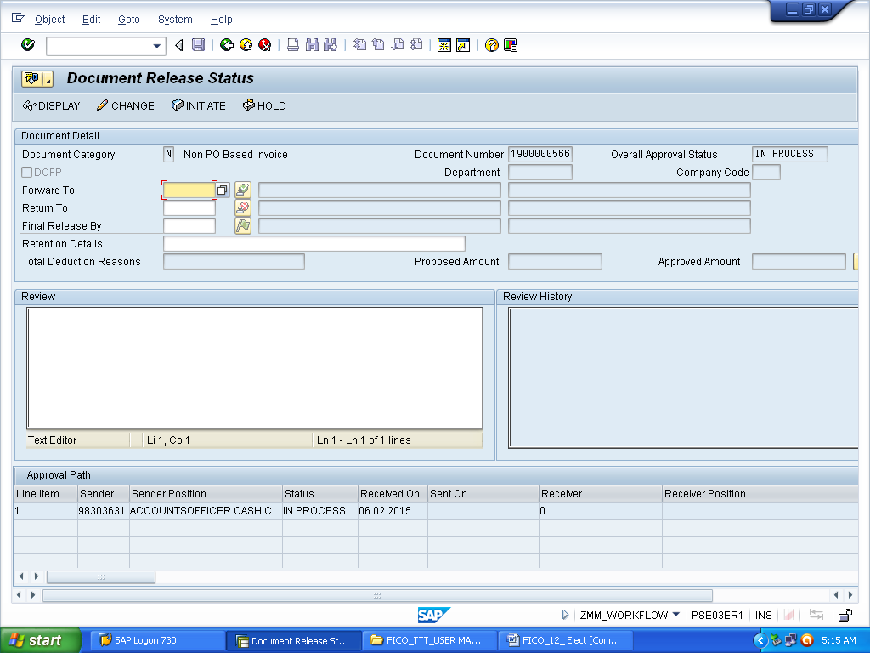

In the forward to text box, enter the pernr of the Authority to whom the file should go next and in the Final Release by text box, enter the pernr of the PGM. In the ‘Review’ text box, note/remarks must be entered . After the above procedure, click initiate.

The workflow for processing Fuel expenditure in ERP is as follows:
SDE (Initiator)
DE
DGM
PGM

DGM(F)
AO(Claims)
CAO(Claims)

